 |  |  |  |  |  |  |  |  |  |  |  |  |  |  |  |  |  |  |  |  |  |  |  |  |  |  |  |  |  |  |  |  |  |  |  |  |  |  |  |  |  |  |  |  |  | o | ns | tr | uct
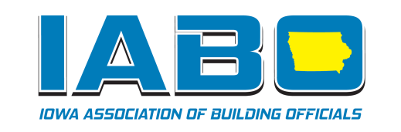

IABO’s Mission
Members of the Iowa Association of Building Officials are committed to promoting safety in the construction of buildings and structures, advancing the professional skills of those engaged in the administration and enforcement of building laws, recommending and promoting uniform regulations, legislation and enforcement pertaining to all phases of building construction through the adoption of the International Codes and related codes and documents and to do all such other things as are incidental to or desirable for the attainment of public safety and wellbeing.

www.iabo.net
 | What is IABO?
Iowa Association of Building Officials (IABO) is the Iowa Chapter of the International Code Council (ICC).

IABO members include:

- Building Officials • Developers
- Building Inspectors • Architects
- Private Inspectors • Engineers
- Local Industry Experts

These professionals want to promote their safety and awareness objectives and the IABO association through awarding two annual scholarships to qualified college students.

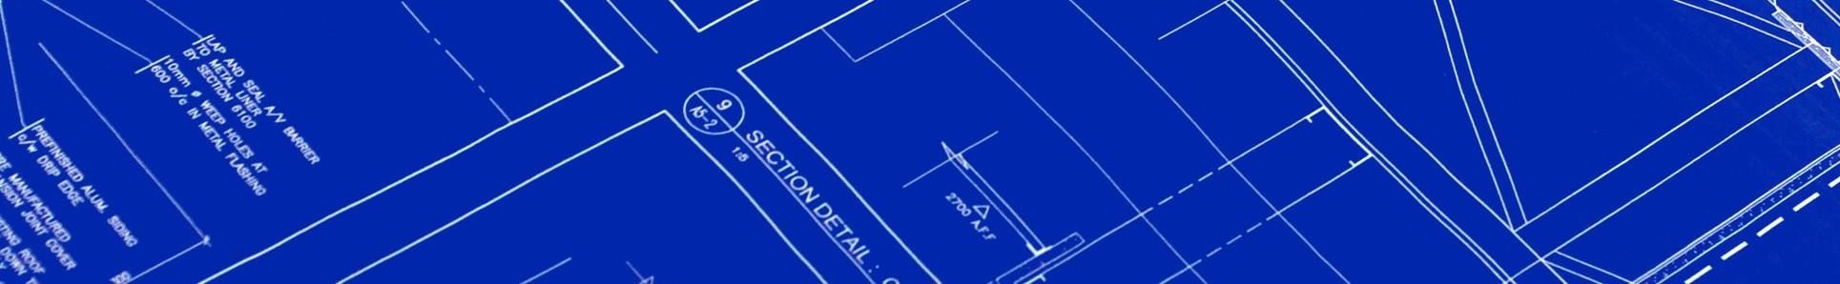
ion Industry Students

scholarship application

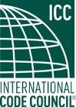
IOWA ASSOCIATION
OF BUILDING OFFICIALS, A CHAPTER OF INTERNATIONAL CODE COUNCIL

Who can apply for the IABO Scholarship?
What will be awarded?
IABO Scholarship Application
All application materials must be received by May 1, 2024
May 1, 2017.
Late or incomplete applications will not be considered.
One 4-year program student will receive $2000.00.

One 2-year program student will receive $1000.00.

Eligible applicants must meet the following requirements:
- Iowa residency
- Iowa high school diploma or GED
- Admittance to, or good academic standing in an eligible program

What programs are eligible?
- Des Moines Area Community College
  - Architectural Technologies or Building Trades
- Inver Hills Community College (MN)
  - Building Inspection Technology
- Iowa State University
  - Architecture or Construction Engineering
- Iowa Western Community College
  - Architectural Engineering Technology
- Kirkwood Community College
  - Architectural/Construction Technology
- Simpson College
  - Pre-Engineering
- Southeastern Community College
  - Construction Technology
- University of Northern Iowa
  - Construction Management
- Western Iowa Technical Community College
  - Design and Drafting Technology
Other schools or curricula that have similar two or four year programs may be considered.

Application Checklist

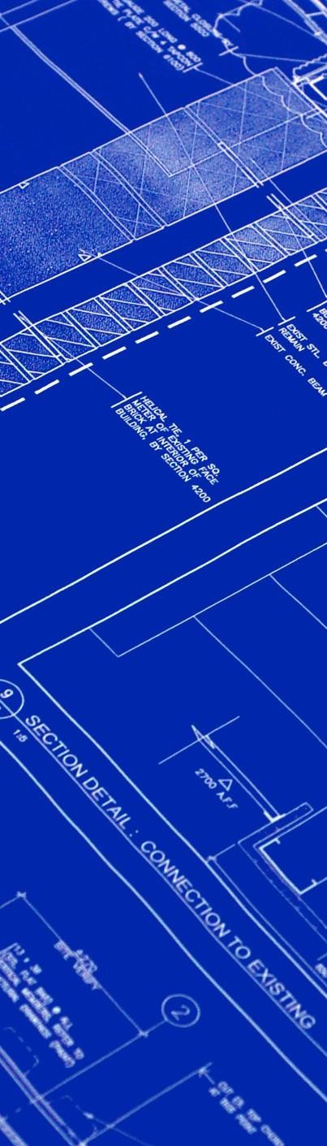
May 1, 2017.
Shelly Bernholtz Safe Building 421 Main Street
Slater, IA 50244

sbernholtz@safebuildingiowa.org

May 1, 2017.
Please print or type the following information:

Full Name:
Date:
Parents/Guardians:
Address:
Telephone Number:
(
Email:
)
What school and program are you planning to attend?
*If you are already attending one of the approved institutions, attach a letter from your advisor detailing your progress towards a degree.
If you have related work experience, briefly detail here:
List other scholarships or financial awards you’ve received:
q Complete the IABO Scholarship Application and detach.
q Acquire your most recent school transcript and letter from advisor (if you are currently enrolled in a program - see application).
q Write a one-page essay about your goals relating to building inspection or construction-related professions. How would receiving this scholarship from IABO help you in attaining these goals?
q Email: Application, Transcript, Letter from Advisor (if necessary) and Goals Essay to: MIKE.BRUCE@DIA.IOWA.GOV

Application and all supporting documentation must be received by:
May 1st. 2024

